**Module-1) Se - Overview Of It Industry**

**1. What is software? What is software engineering?**

Ans: software is a set of instructions or program tells computer what to do, software engineering is the process of designing , developing, testing and maintaining software it is called software engineering.

**2. Explain types of software.**

Ans : Software's are broadly classified into two types, i.e., System Software and Application Software. 1. System Software System software is a computer program that helps the user to run computer hardware or software and manages the interaction between them

3. What is SDLC? Explain each phase of SDLC

Ans : SDLC, or software development life cycle, is a methodology that defines the entire procedure of software development step-by-step.

1**.** [Requirements gathering and analysis:](https://www.geeksforgeeks.org/requirements-gathering-introduction-processes-benefits-and-tools/) This phase involves gathering information about the software requirements from stakeholders, such as customers, end-users, and business analysts.

2. Design: In this phase, the software design is created, which includes the overall architecture of the software, data structures, and interfaces. It has two steps:

· High-level design (HLD): It gives the architecture of software products.

· Low-level design (LLD): It describes how each and every feature in the product should work and every component.

3. Implementation or coding: The design is then implemented in code, usually in several iterations, and this phase is also called as Development.

things you need to know about this phase:

· This is the longest phase in SDLC model.

· This phase consists of Front end + Middleware + Back-end.

· In front-end:Development of coding is done even SEO settings are done.

· In Middleware: They connect both the front end and back end.

· In the back-end**:** A database is created.

4. Testing: The software is thoroughly tested to ensure that it meets the requirements and works correctly.

5. Deployment: After successful testing, The software is deployed to a production environment and made available to end-users.

6. Maintenance: This phase includes ongoing support, bug fixes, and updates to the software

**4. What is DFD? Create a DFD diagram on Flipkart**

Ans: DFD stands for data flow diagram it represent the flow of data within information system. It provides graphical representation of the data

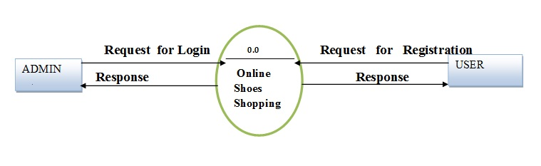

**5. What is Flow chart? Create a flowchart to make addition of two numbers**

Ans: A flowchart is a diagrammatic representation of an algorithm or a process.

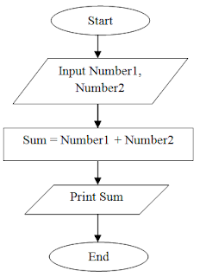

**6. What is Use case Diagram?**

**Ans**: A Use Case Diagram is defined as a graphical representation of the interactions between users (actors) and a system. It illustrates the various ways in which users interact with a system to achieve specific goals or tasks.